Syeda Reeha Quasar

14114802719

4C7

Aim

Introduction to NS3 and its comparison with NS2.

Experiment - 2

Computer Networks Lab

# **EXPERIMENT – 2**

## **Aim:**

Introduction to NS3 and its comparison with NS2.

## **Theory:**

The ns-3 simulator is a discrete-event network simulator targeted primarily for research and educational use. The ns-3 project started in 2006, is an open-source project developing ns-3.

Ns-3 has been developed to provide an open, extensible network simulation platform, for networking research and education. In brief, ns-3 provides models of how packet data networks work and perform, and provides a simulation engine for users to conduct simulation experiments. Some of the reasons to use ns-3 include performing studies that are more difficult or not possible to perform with real systems, studying system behavior in a highly controlled, reproducible environment, and learning about how networks work. Users will note that the available model set in ns-3 focuses on modeling how Internet protocols and networks work, but ns-3 is not limited to Internet systems; several users are using ns-3 to model non-Internet-based systems.

A few key points are worth noting at the onset:

* Ns-3 is open-source, and the project strives to maintain an open environment for researchers to contribute and share their software.
* Ns-3 is not a backwards-compatible extension of ns-2; it is a new simulator. The two simulators are both written in C++ but ns-3 is a new simulator that does not support the ns-2 APIs.

Many simulation tools exist for network simulation studies. Below are a few distinguishing features of ns-3 in contrast to other tools.

* Ns-3 is designed as a set of libraries that can be combined together and also with other external software libraries. While some simulation platforms provide users with a single, integrated graphical user interface environment in which all tasks are carried out, ns-3 is more modular in this regard. Several external animators and data analysis and visualization tools can be used with ns-3. However, users should expect to work at the command line and with C++ and/or Python software development tools.
* Ns-3 is primarily used on Linux or macOS systems, although support exists for BSD systems and also for Windows frameworks that can build Linux code, such as Windows Subsystem for Linux, or Cygwin. Native Windows Visual Studio is not presently supported although a developer is working on future support. Windows users may also use a Linux virtual machine.

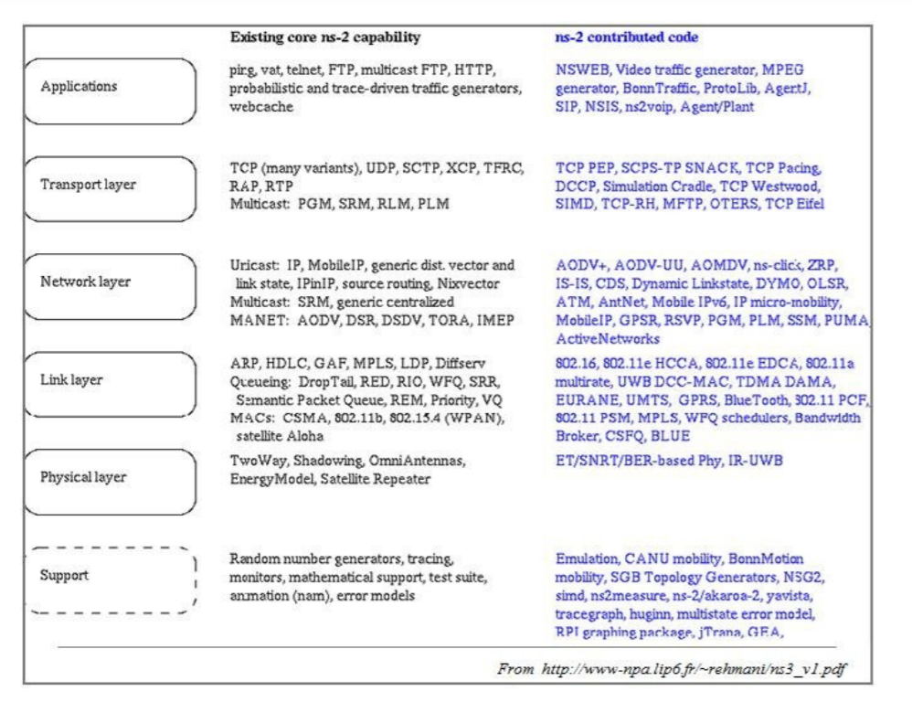

**Ns2 contributed code**

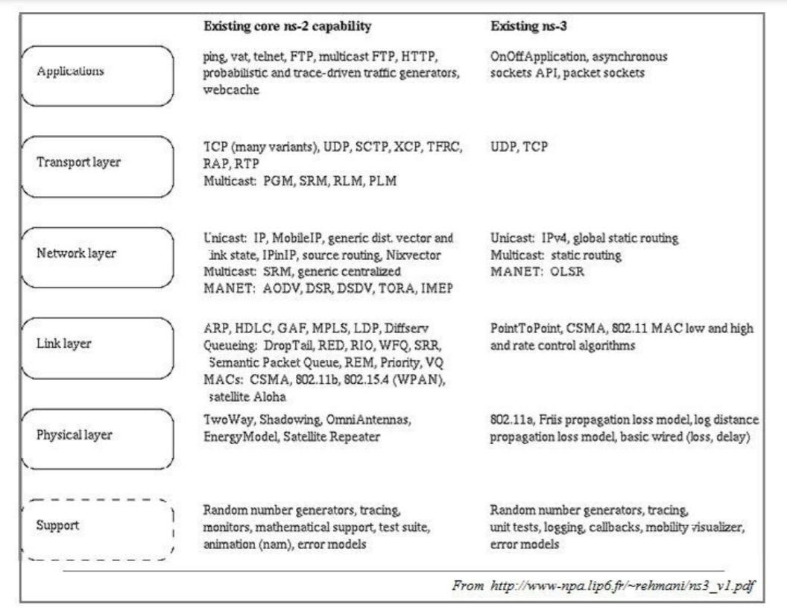

**NS2 and NS3 existing core capabilities**

**COMPARISON BETWEEN NS3 AND NS2**

**Application-level difference between NS3 and NS2**

|  |  |
| --- | --- |
| **NS3** | **NS2** |
| NS3 can act as the emulator that it can connect to the real world. | NS2 cannot act as the emulator. |
| Some of the NS2 models can be imported to NS3. | NS3 scripts cannot run in an NS2 environment |

**Programming Language level Difference between NS2 and NS3:**

|  |  |
| --- | --- |
| **NS3** | **NS2** |
| NS3 is written using C++ | NS2 is written with the help of TCL and C++ |
| Compilation time is not a matter | C++ recompilation takes more time more than TCL so most of the scripts are written using TCL |
| A Simulation script can be written in ns3 | Simulation script is not possible with NS2 |
| Python is available for the scripting language. | Only TCL can be used as the scripting language. |

**Packets difference in NS2 and NS3:**

|  |  |
| --- | --- |
| **NS3** | **NS2** |
| Information needed to send through the packet can be added at the header, trailer, buffer ,etc. | The header part of the NS2 includes all the information of header parts in the specified protocol |
| NS3 frees the memory that used to store the packets | NS2 never reuse or re allocate the memory until it gets terminated. |

**File Format Difference between NS2 and NS3:**

|  |  |
| --- | --- |
| **NS3** | **NS2** |
| .tr-> files used for trace analysis | . tr-> files used for trace parameters |
| .XML->files are used for network Animation | .nam -> files used for Network Animation |
| .csv-> files used for gnu plot | .xg -> files used for graph |

**Visualization Difference between NS2 and NS3:**

|  |  |
| --- | --- |
| **NS3** | **NS2** |
| Python visualizer , Network Animator visualization is available | Nam animator is available for visualization |

**Performance level difference between ns2 and ns3:**

|  |  |
| --- | --- |
| **NS3** | **NS2** |
| Memory allocation is good | Memory allocation is not good as NS3 |
| The system prevents unnecessary parameters to be stored. | Unnecessary parameters cannot be prevented. |
| Total computation is less when compared to NS2 | Total Computation time is high when compared to NS3 |